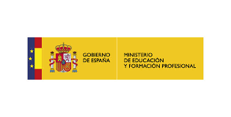

- CEIP “PADRE MANJÓN”
- C/ Padre Manjón, nº 18. 03600 ELDA (Alicante) Tfno. 96 6957430 / Fax: 96 6957431
e-mail: 03005422@gva.es - www.padremanjonelda.es

LETTER TO A TEACHER IN PRACTICE

Dear Sofia,
It has been a pleasure to have you at our centre. We hope that we have helped you sufficiently in taking the decision to dedicate yourself to teaching.
We are convinced that this is one of the best professions in the world if you are really passionate about it. We wish you luck in your professional future, and we want you to know that you will always be welcome at this centre, that your contributions and assistance during the internship have been taken into account and are valued, and that, in the same way, we hope to have contributed a little more to your teacher training.
With your decision to dedicate yourself to teaching, you have become a part of the family of professionals who believe in utopia, in the growth of all people, in the possibility of improving what surrounds us, and therefore, in contributing to a better future and a better society.

And we are confident that you have extracted the most out of this experience.
Good luck! If you need anything, we are right here.
CEIP Executive Team Padre Manjón- Elda

